iOne360 Configurator plugin user documentation for WordPress

Installation & Usage

Step 1. unzip the contents of the configurator package in the / wp-content/plugins/ folder.

Step 2. the configurator will now show up in the plugins tab of your WordPress plugins list.


Step 3. Press the activate button to add the configurator plugin to your WordPress site.

The plugin adds the iOne Configurator settings tab to your admin sidebar.

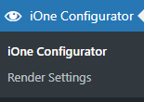
You will be able to store your iOne Configurator settings here.

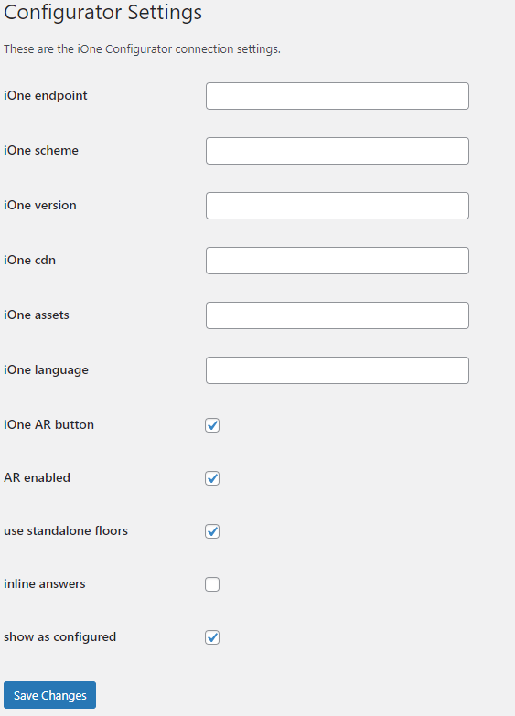

Along with specific render settings
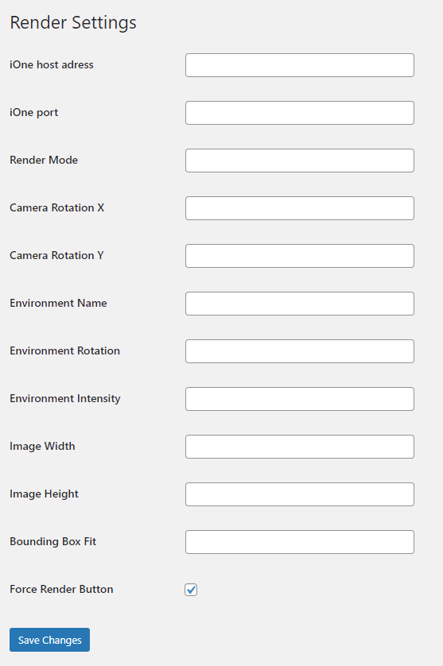

Selecting Template

On the pages tab in the backend, press the ‘Add New’ page button.

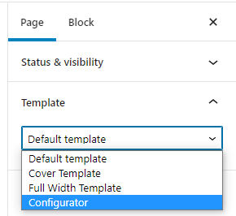

If the configurator plugin for wordpress was installed correctly, you will be able to select the template here.

For the purposes of this documentation, we have named the page Configurator, follow the next steps to finish setting up the configurator page.
Adding Custom field & SKU

In order to add a SKU for the configurator, you need to add a custom field.

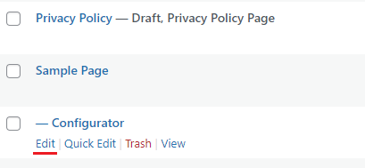

In the backend, go to the pages tab and click to edit your page.

Then in the top right, press the options button (the 3 dots) to access the preferences menu.

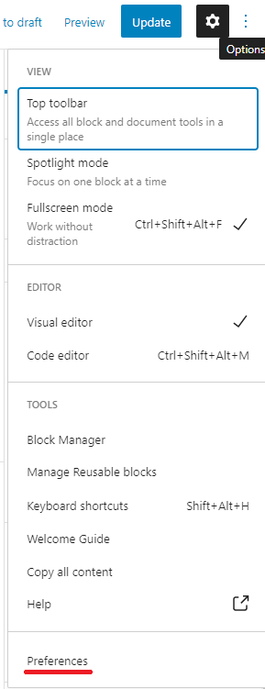

Go to the panels tab and activate the custom fields option.
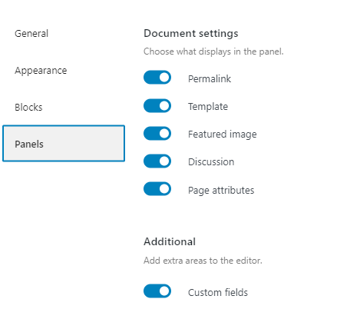

This will add a new tab to your page edit.

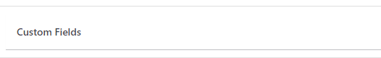

This will allow you to add a custom data field for the configurator.
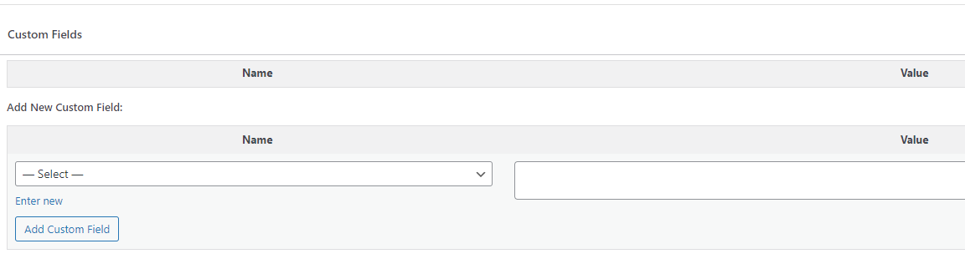
Press enter new and type in ‘configurator sku’ and fill in the value of the SKU of the product you wish to display.

After updating, the page will now display the configurator with the product you chose.

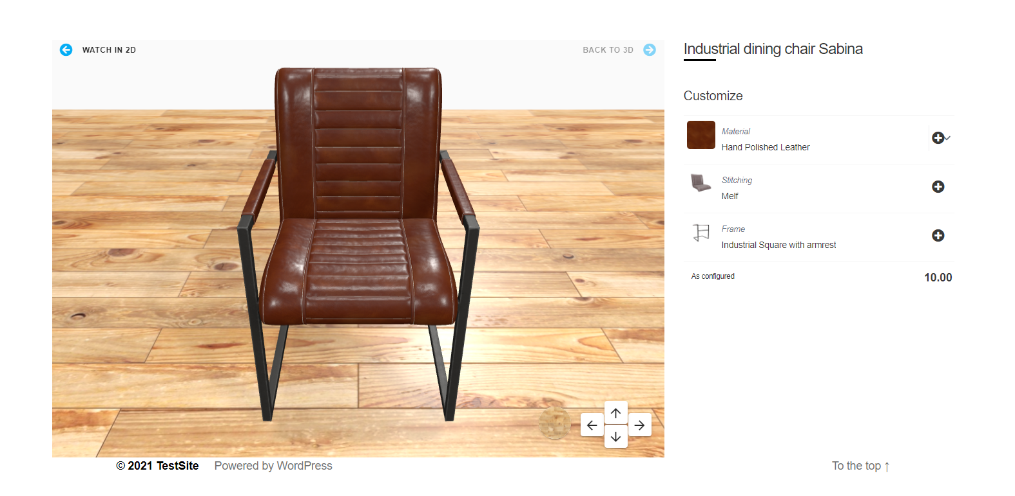
(example of the configurator working)

iOne360 Configurator plugin user documentation for Woocommerce

Installation & Usage

Step 1. unzip the contents of the configurator package in the / wp-content/plugins/ folder.

Step 2. the configurator will now show up in the plugins tab of your WooCommerce plugins list.

Step 3. Press the activate button to add the configurator to your WooCommerce site. This will add the option of making a product a ‘Configurator Product’. When editing products in the back-end.


It will add the following tab to a product’s page in the back-end.
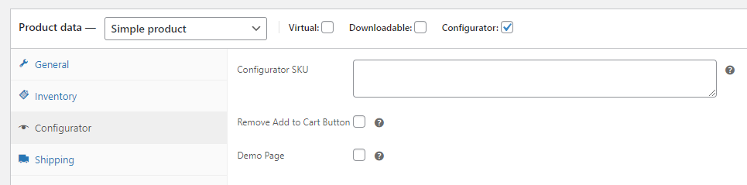

Here you can add the specific SKU for the configurator, remove the ‘Add to Cart’ button from this specific product and enable ‘Demo Page’ which replaces the normal product summary with the configurator.

The plugin adds the iOne Configurator settings tab to your admin sidebar.

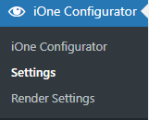
You will be able to store your iOne Configurator settings here.

Along with specific render settings
Once you’ve specified that a product is a ‘configurator’ product, the plug-in will add a button on the specified product’s page.


Pressing this button will open up a new screen, where you can configure the product with selections on the right hand side. With these selections it will display a new price ‘as configured’, which is the price that will end up in the cart.

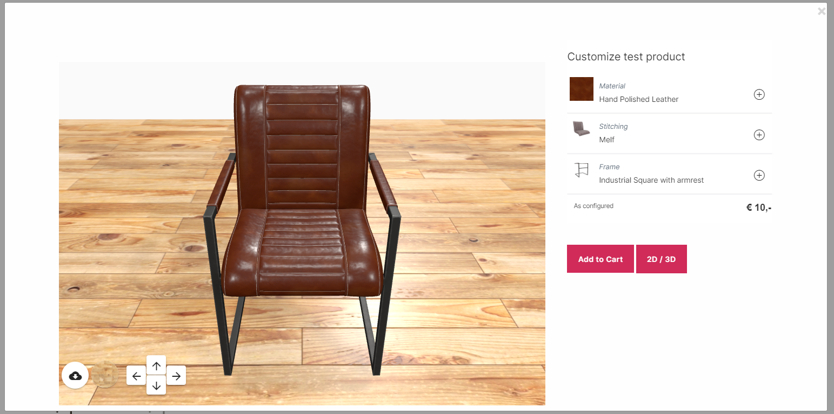
(example of a product being configured in the window)

Pressing add to cart here will add the product to the cart along with a description of the selection made in this window.

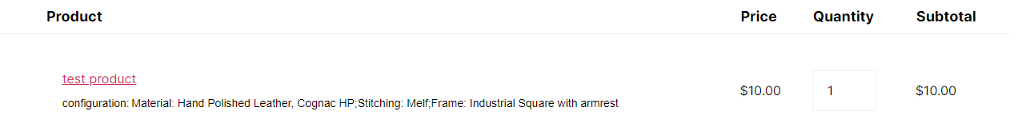

Pressing the 2D / 3D button allows you to switch from a 3d to a 2d render (or vice versa) of the product.

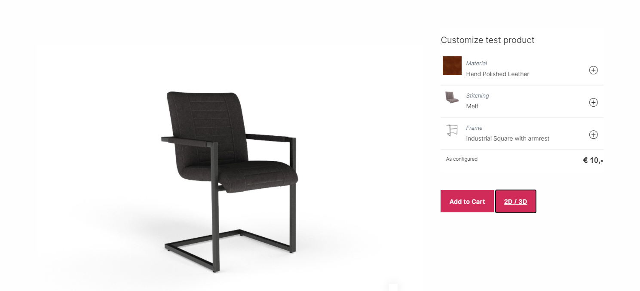
(example of a 2D render of the same product used earlier)

Making selections on the right hand side will change the render of the product without reloading the window. A brief loading image will show up while it retrieves the new render.

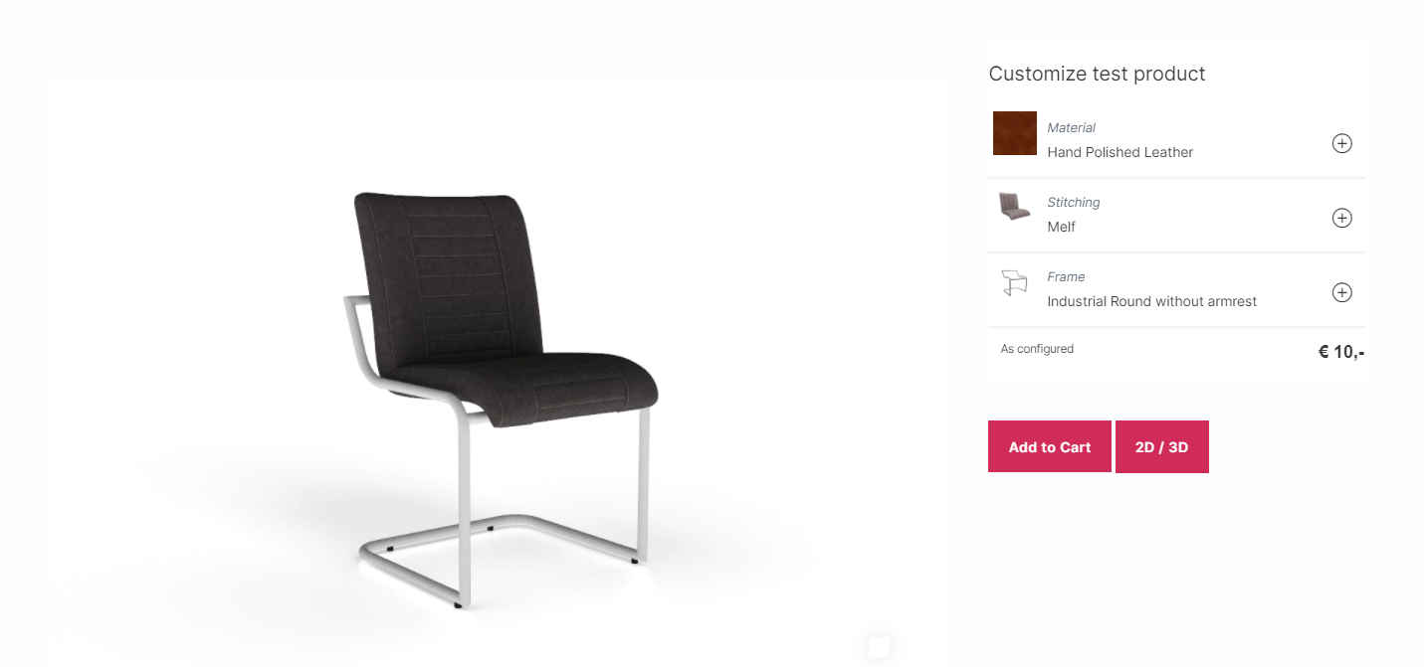
(the same product as earlier but the selection for the frame is changed)

